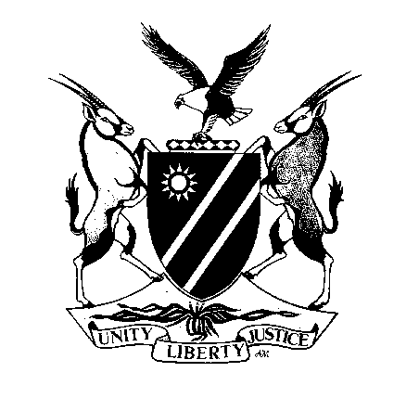
REPUBLIC OF NAMIBIA

MINISTRY OF MINES AND ENERGY

OFFICE OF THE MINING COMMISSIONER

APPLICATION FOR A NON-EXCLUSIVE PROSPECTING LICENCE (NEPL)
(NATURAL PERSON)

(Required in terms of section 18 of the Minerals (Prospecting and Mining) Act, 33 of 1992)

Have you previously been issued with a NEPL?
YES
NO
If “Yes”, indicate the NEPL number previously allocated: ………………………………………………..…………………..
Full Name of Person: ……………………………………………………………………………………………………………………………………..

……………………………………………………………………………………………………………………………………………………………….

Nationality: ……………………………………………………….. Date of Birth (DD/MM/YY): ……………………………………………………..

Passport /Identification Number: ………………………………………………………………………………………………………………………..

Permanent/Temporary Residence/Work Permit No.: …………………………………….. Date of Expiry: …………………….…………………

Postal Address: ………………………………………………………………………………………………………….………………………………..

……………………………………………………………………………………………………………………………………………………………….

Residential Address: ……………………………………………………………………………………………………………………………………...

……………………………………………………………………………………………………………………………………………………………….

Tel No. (h): …………………………………… Tel No. (w): ……………………………. …………. Fax No.: ……………………………………...

Email Address: ……………………………………………………………………………………………………………………………………………

In the case of a person who is not resident in Namibia and who is required to be represented by an approved accredited agent:

Full Name of Accredited Agent: …………………………………………………………………………………………………………………………

Residential Address: ……………………………………………………………………………………………………………………………………...

……………………………………………………………………………………………………………………………………………………………….

Postal Address: ………………………………………………………………………………………………………….………………………………..

Tel No. (h): …………………………………… Tel No. (w): ……………………………………….. Fax No.: ……………………………………...

Email Address: ……………………………………………………………………………………………………………………………………………

In the case of a person who has been convicted of an offence by a court of law in respect of which the person was sentenced to imprisonment, whether suspended or not, without the option of a fine:

Date of Conviction: ………………………………………………………. Place of Conviction: …………………………………………………….

* Nature of Offence: ……………………………………………………… * Sentence: ……………………………………………………………...

* (Append separate sheet if necessary)

* Furnish details of any matter which in the opinion of the applicant is relevant to the application (if any):

……………………………………………………………………………………………………………………………………………………………….

……………………………………………………………………………………………………………………………………………………………….

……………………………………………………………………………………………………………………………………………………………….

* (Append separate sheet if necessary)

Certified copies of the following documents must be attached to this application:

- National Identity Document or National Passport with clear photo.
- In respect of an applicant represented by an accredited agent (AA), the
- Written acceptance of such designation by AA, and the
- Written approval of the Mining Commissioner of the designation of the AA.

The prescribed fee of N$ 250-00 must be paid in favour of the Ministry of Mines and Energy.

I declare to the best of my knowledge that the information in this application is true and correct.

________________________ ________________________ ______________

SIGNATURE OF APPLICANT FULL NAME OF APPLICANT DATE

Kindly note that in terms of the provisions of section 133(b) and (c) of the Minerals Act, No. 33 of 1992, that any person who:
- makes or causes to be made in connection with the provisions of the Act any statement which is false or misleading knowing it to be false or misleading; or
- submits or causes to be submitted in connection with any application or any notice, report, return or statement issued or given under any provision of the Act or the terms and conditions of any non-exclusive prospecting licence, mining claim or mineral licence, any document, information or particulars which are false or misleading knowing them to be false or misleading;

shall be guilty of a criminal offence and on conviction liable to a fine not exceeding N$ 8 000-00 or to imprisonment for a period not exceeding 12 months or to both such fine and such imprisonment.

